# **WEEK 2 SLF4J LOGGING HANDS ON**

**SUBMITTED BY :-**

NAME – AYUSH SAHOO

SUPERSET ID – 6372243

COURSE – DIGITAL NURTURE 4.0 JAVA FSE

EMAIL – [ayush.sahoo003@gmail.com](mailto:ayush.sahoo003@gmail.com)

COLLEGE – C.V. RAMAN GLOBAL UNIVERSITY

**Exercise 1: Logging Error Messages and Warning Levels Task: Write a Java application that demonstrates logging error messages and warning levels using SLF4J.**

**SOLUTION:-**

Step 1:- Create a another file name “SLF$JLogging.java” then place

• slf4j-api-1.7.30.jar

• logback-classic-1.2.3.jar

• logback-core-1.2.3.jar

In lib folder

Step 2:-

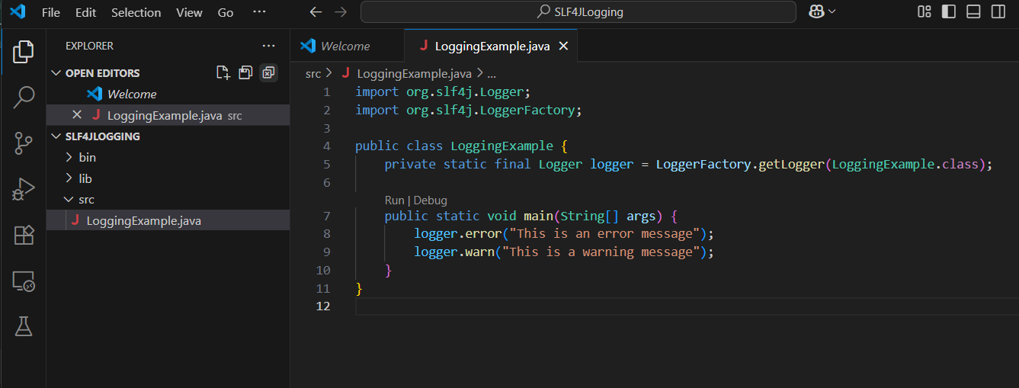

**OUTPUT:-**

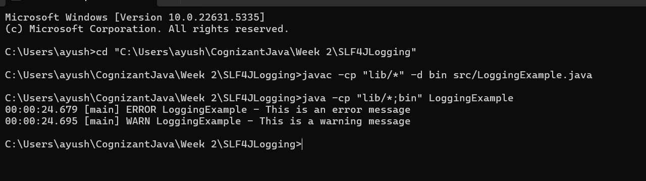

**x----x----x**